Self and Peer assessment form for COM109 Coursework 2

Please assess your contribution to the preparation of the solution to the COM109 coursework in relation to that of your other team member.

Did each of you contribute equally? If so, each team member will be given an equitable apportioning of the marks. For non-equitable efforts, those contributing less than their fair share will receive a scaled mark accordingly.

Allocate a mark for each member of your team. Ensure that the marks together total 100.

Group ID (eg: subGroupA):

Peer Contribution Evaluation

Group Member Name | Student ID | Estimated Contribution (%)
 |  | 25%
 |  | 25%
 |  | 25%
 |  | 25%
Total |  | 100%

What particular responsibility/tasks did each team member undertake during the preparation of the assignment solution?
completed: (1) Gallery and Reviews page; (2) responsive CSS; (3) reservation validation; (4) Cookie Consent Banner; (5) navigation fixes; and (6) GitHub maintenance.
completed: (1) reservation page; (2) responsive design; (3) booking JavaScript and localStorage; (4) confirmation and receipt features; (5) link fixes; and (6) testing and GitHub maintenance.
completed: (1) Menu page; (2) responsive styling and filtering; (3) Admin Dashboard; (4) booking search and statistics; (5) CSV export; and (6) testing and GitHub maintenance.
completed: (1) Staff Portal Login; (2) shared style.css; (3) responsive CSS; (4) reusable utils.js; (5) resource and navigation fixes; and (6) testing and documentation, GitHub control.

Self-Assessment Checklist
Task | Yes / No
- Created HTML structure and web pages | Yes
- Styled the site using CSS (including responsiveness) | Yes
- Developed JavaScript functionality (animations, validation) | Yes
- Worked on form validation and user input handling | Yes
- Integrated accessibility features | Yes
- Managed version control (GitHub) | Yes
- Documented code and wrote report sections | Yes
- Debugged issues and tested functionalities | Yes
- Organised group meetings & coordinated tasks | Yes
- Packaged and submitted final assignment files | Yes

Repository Link: https://github.com/Satirtha7/Book-IT

Introduction
This report presents my individual contribution to The Golden Leaf Restaurant Website, my main area of responsibility was the development of the reservation system. I created the reservation page using bibash.html, designed its interface with bibash.css, and implemented the booking functionality through booking.js. I also developed storage.js, which provides client-side storage for reservation records using the browser’s localStorage.
It enables input selection for name email phone etc. choose a date and time, number of guests, Occasion and special request. When click create button, the system stores it and shows the booking confirmation receipt. I was also responsible for responsive enhancements, navigation and footer links, providing favicon, documentation of the project.
I first identified the different customer journeys like filling personal details, selecting a date, time of arrival and number of guests, choosing the occasion and adding custom requests during the booking. I listed and laid out the form elements in the form fields and grouped the related inputs like form-row/form-group to make the layout a lot better rather than having all of them in a long list at once.
I also planned the validation rules for the customer side such as a maximum of 10 guests only and a no-past-date booking. About the way of handling data on the customer side, I planned localStorage to be the solution so that the storage logic will not be in the same booking.js file with it but instead a separate storage.js module which can be reused by other components like the Admin Dashboard. Also, I included in my plan to create a confirmation modal and a download receipt button as a part of the main user experience features and not just the least important ones.

Description of HTML Code for the Reservation Page
The primary HTML file that I developed is bibash.html, which lays out the restaurant's website and reservation system interface.
The page follows typical HTML5 practices and is designed to automatically scale using viewport settings, so the layout remains consistent across all devices. I also included metadata that could help with the search engines like title description keywords and other Open Graph elements. To enable the web design and animation, external assets like Google Fonts, Font Awesome and AOS have been linked in this document.
One of the major UI features of the page is a navigation bar containing links to the first page, About us section, Our Menu Gallery Reviews and Booking.I also included the mobile menu button used by the project’s common JavaScript functionality.
The central part of the page is the reservation form. I divided the form into logical groups so that related information is presented together. Users will be asked to provide their full name, phone number, and email address. They can also pick an occasion like Birthday Anniversary Corporate or Family Dinner.
At booking section, reservation dates, time slot and number of guests fields are also available. The guest input only allows input up to between 1 and 10. Besides, there were checkboxes added for special needs like wheelchair access, a high chair, and a preferred window seat.
Before submission button, the user is required to check the terms and conditions/cancellation of a bookings box. The user is hereby forced to be aware of the terms of their bookings after submitting a request.
HTML success modal is another important section of the web. When a booking is successfully created, modal pops up the confirmation message with the booking ID, date & time, the number of people, and the occasion selected. Also, there are controls on the modal for downloading a receipt or to the homepage.
The page also contains a footer with restaurant information, navigation and social media links. During later development, I corrected links and added the favicon as recorded in my Git history.
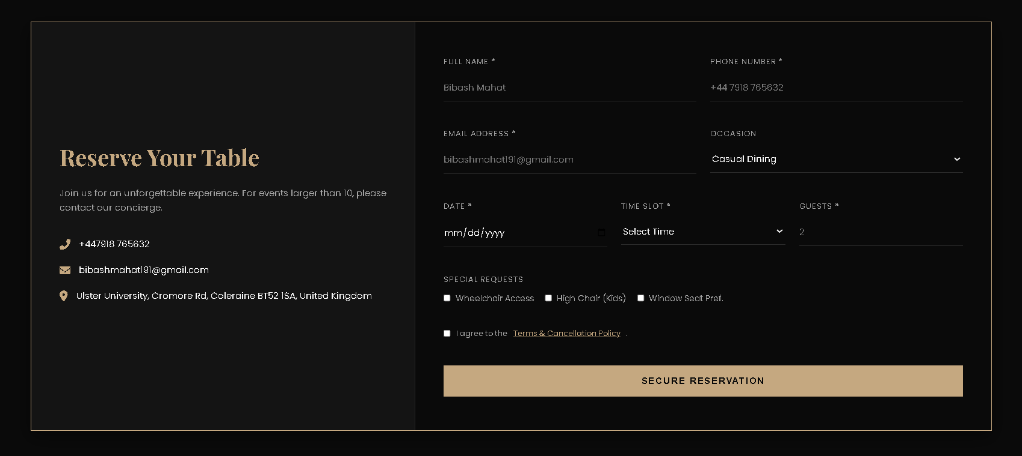
Figure 1: Reservation page showing the booking information and contact section.

Description of CSS Code for the Reservation Page
The visual appearance of the reservation system is controlled mainly through bibash.css. I created the styling to match the dark and premium visual identity of The Golden Leaf website.
The .booking-section uses a large background image with a dark overlay. This creates a restaurant-themed background while maintaining enough contrast for the booking interface. The main .booking-container uses Flexbox to divide the section into two areas: the information panel and the reservation form.
The .booking-info area contains the restaurant heading and contact details. The heading uses the project’s gold colour and heading font, while the contact information uses icons from Font Awesome to make the details easier to recognise.
The booking form occupies the remaining area through .booking-form-wrapper. I used .form-row and .form-group classes to organise the inputs into a structured layout. Text, telephone, email, date and number inputs share a consistent visual style with transparent backgrounds and bottom borders. When an input receives focus, its border colour changes to the project’s primary gold colour, giving the user clear visual feedback.
The checkbox area was also styled so that the special-request options are displayed neatly and can wrap when there is insufficient horizontal space. The reservation button uses the primary gold colour and includes a hover transition.
I also designed the confirmation modal. It is positioned over the page using a fixed overlay and displays the booking information inside a bordered content panel. The receipt information is separated into a .receipt-box, while the action buttons are grouped together for a clear layout.
I later made responsive adjustments to the reservation styling for smaller devices. My Git history includes a specific commit for updating bibash.css for responsive mobile behaviour.
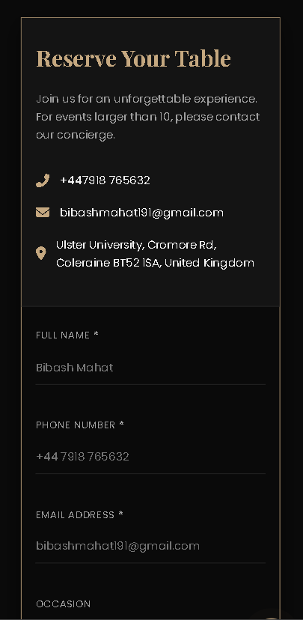
Figure 2: Responsive reservation page on a smaller screen.

Description of JavaScript Code
The main reservation functionality is implemented in booking.js. The script waits for the document to load before locating the booking form, modal, buttons and date input.
One of the first functions prevents users from selecting a date in the past. The current date is obtained using JavaScript and assigned as the minimum value of the booking date field. This helps ensure that reservations cannot be intentionally created for dates that have already passed.
When the reservation form is submitted, the default browser submission is prevented. The script then collects the selected special requests by finding all checked .special-req elements.
A booking object is created containing the reservation details. This includes a generated booking ID, customer’s name, phone number, email, occasion, date, time, number of guests, special requests, booking status and creation timestamp. The booking is initially assigned the Confirmed status.
The completed booking object is then passed to Storage.saveBooking(). After the information has been stored, the confirmation modal is populated with the customer’s email, booking ID, date, time, number of guests and occasion.
The modal is then displayed and the form is reset. I also included a custom bookingUpdated browser event so that other application-level functionality can detect when a new reservation has been created.
The modal contains a close button that hides the confirmation window. I also implemented the receipt download functionality using html2pdf. Before creating the PDF, the modal action buttons are temporarily hidden so that they do not appear unnecessarily in the downloaded receipt.
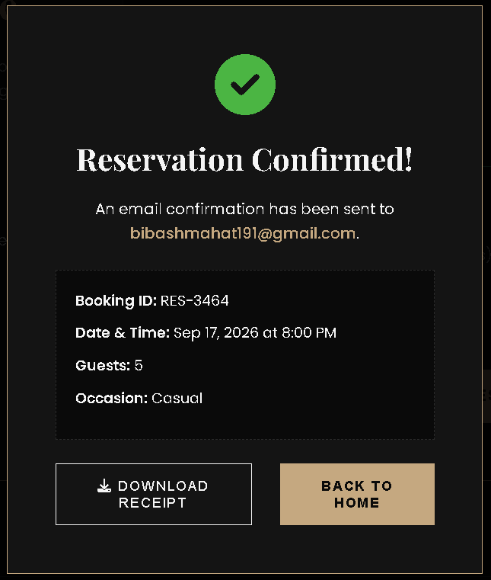
Figure 3: Reservation confirmation modal after successful booking.

Client-Side Storage Implementation
I also developed storage.js to provide a simple client-side data storage system for the reservation functionality.
STORAGE_KEY is a constant that holds one value that can be changed, which in this case is a variable that helps us recognize the reserve data. The getAllBookings() method reads the stored JSON data of the booked rooms and then converts it back into a JavaScript one-dimensional array. The method returns a "empty" list if no bookings have been made.

Before saveBooking() puts a new booking in the array, it gets the previously saved bookings, appends the new booking, then stores the combined data back into localStorage as a string by using JSON.stringify().
I also created getLiveStats(), which calculates basic table availability information. The function works with a total of 20 tables and 3 VIP tables. It checks today’s bookings and calculates the number of booked and available tables. The result provides the booked count, available tables and available VIP tables.
This storage approach allows reservation data to remain available within the browser and also allows other project components, such as the Admin Dashboard, to access the same booking information.
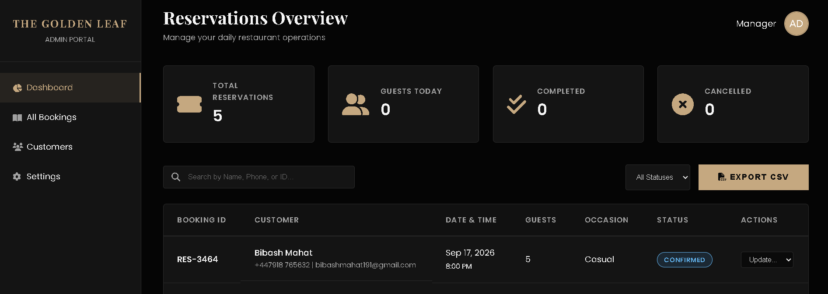
Figure 4: Reservation data stored through the booking system.

Testing and Validation
I tested the reservation system to confirm that the main booking features worked as expected. Firstly, the reservation form was scrutinized for compulsory data entries, valid booking dates, selecting the right time slots, guest numbers, occasions, and making any special requirements. Having successfully submitted the form, I confirmed the reservation was stored properly and that the confirmation modal contained accurate reservation data
I also tested the modal controls and receipt download function, including checking that booking information was stored in localStorage. In addition, I tested the page on smaller screen sizes to validate the responsive layout and corrected navigation and footer-link issues. These improvements are also reflected in my GitHub commits, including responsive updates, link corrections, favicon integration, and JavaScript/storage changes.

Conclusion
My contribution to The Golden Leaf Restaurant Website was mainly focused on creating the online reservation system and its supporting client-side data functionality. I developed the complete reservation page structure in bibash.html, created the visual presentation in bibash.css, and implemented the booking workflow through booking.js.
The reservation system allows users to provide their details, choose a booking date and time, specify the number of guests, select an occasion and add special requirements. After submission, the system generates a booking record, stores it using browser local storage and presents a confirmation receipt.
The development of storage.js was also an important part of my contribution because it provides a reusable method for saving and retrieving reservation records. Its live statistics function also allows the wider project to access basic table availability information.
In addition to the main booking functionality, I improved responsive behaviour, corrected navigation and footer links, added favicon support and maintained the project documentation. My GitHub commit history shows the progression from the initial HTML and CSS implementation through JavaScript, storage, responsive improvements and final integration work.
By using version control, the coursework has required that students demonstrate their individual contributions, and my Git repository shows the whole journey of this development.
Besides that, the reservation system has allowed me to deepen my knowledge in various areas including HTML forms, CSS layouts, JavaScript event handling, web browser local storage and client-side communication. On top of that, it was my opportunity to learn how to incorporate a single functionality on a website that is being worked on by multiple persons. During my work, I was focused on preserving uniformity in navigation, styling, and responsive behaviour.

